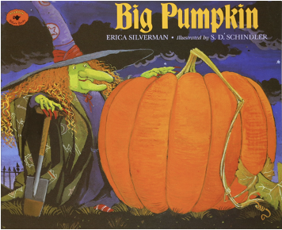
Big Pumpkin
Suggested Grade Level: Grade One

Objectives:
- Octave Bordun
- Vocal Exploration

Materials:
- Book Big Pumpkin by Erica Silverman
- Barred Instruments for Accompaniment
- “Scripts” with lines for each of the different characters (I find it easy to use presentation slides)
- Sound effect instruments for the following events in the story (Use suggestions below or have students choose):

Pumpkin seeds being planted – Barred instruments notes separately
Weeding and Watering – Barred instruments glissandos
Sprout poking through – Barred instruments single conducted note
Pumpkin growing – Barred inst. tremolo starting low and getting higher
Pulling the pumpkin – Guiro
Tugging the pumpkin - Ratchet
Kicking the pumpkin – Cowbell
Pumpkin snapping off the vine – Slapstick
Pumpkin flying away – Tone Pipe
Pumpkin landing and rolling down the hill – Tubano Drum

- Explain to the class that you will be adding a song to a story that you will be reading to them. As they listen to the story, ask the students to try and keep track of all of the “Halloween” characters in the story and the order in which they appear. (Witch – Ghost - Vampire – Mummy – Bat)
- Teach students the song and then introduce them to the Octave Bordun accompaniment part through speech and body percussion. Have class perform accompaniment using speech and body percussion while you sing the song.
- Transfer accompaniment to barred instruments. Have class perform accompaniment on barred instruments while the teacher and class sing the song.
- Have class practice lines for each of the characters allowing them the opportunity to explore different voices. Ask for student volunteers to portray each of the characters.
- Discuss sound effects needed for the story and assign instruments and instrument players for each.
- Perform the story with orchestration, actors, and sound effects. On another day repeat activity allowing students to try a different part.

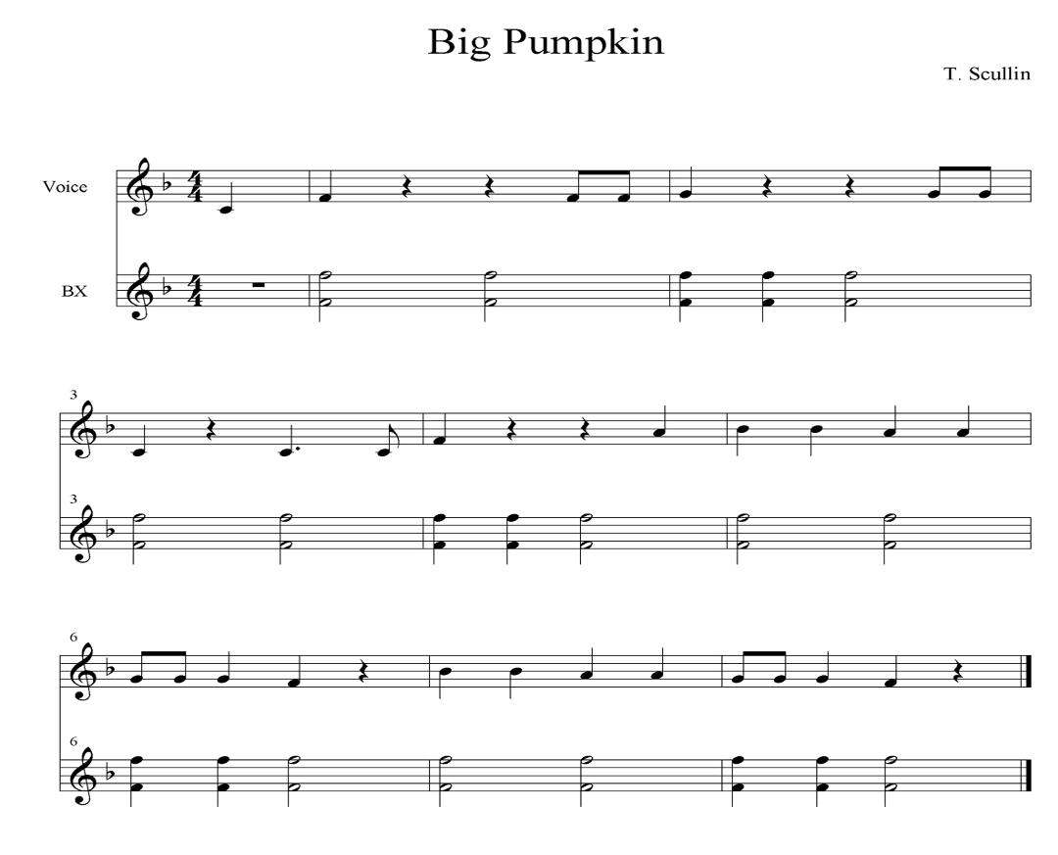

Ghostbusters Dance
Suggested Grade Level: Grade Four

Objectives:
- Students will be able to follow musical form using movement
- Students will be introduced to traditional dance steps

Materials:
- Visuals of dance directions
- Audio recording of Ghostbusters

- Display visual of dance directions for slide one. Ask students to notice any parts that repeat. Verbally explain all movements to the students before asking them to choose a partner and form two lines facing each other. When students have formed two lines, begin practicing the dance directions for slide one.

Forward 4 – Take four steps toward your partner
Back 4 – Take four steps back to your original spot
Trade places with partner 8 – Take eight beats to walk across and take your partner’s place
Head couple down alley 8 - Partners nearest the music walk down middle of two lines
Head couple back up alley 8 – Same partners head back up the middle to original spots

- Display visual of dance directions on slide two. Ask students to notice if there any changes from slide one and if there are any new parts. (Change: Only one Forward Back & Trade this time, New: Nothing) Practice dance directions for slide two.

- Display visual of dance directions on slide three. Ask students to notice if there any changes from slide one and if there are any new parts. (Change: Only one Forward Back & Trade this time, No Peel the Banana or arch, New:V Step Pose) Practice dance directions for slide three.

V Step Pose – One Arm Up, Other Arm Up, One Leg Out, Other Leg Out, Pose

- Display visual of dance directions on slide four. Ask students to notice if there any changes from slide one and if there are any new parts. (Change: Only one Forward Back & Trade, Pause to add the new step before peel the banana: New: Zombie Circles) Practice dance directions for slide four.

Zombie Circles – Arms out like zombie, One foot planted, other foot pivots in circle
- Display visual of dance directions on slide five. Ask students to notice if this is like any other slide we have already practiced. (Slide Two) Practice dance directions for slide five.
- Display visual of dance directions on slide six. Ask students to explain what makes this slide different from the others. (It only has the very beginning two steps.) Practice dance directions for slide six.
- Practice all slides with music. Repeat giving many students a chance to be head couple.

